**Adaptive Synchronization of Uncertain Fractional Order Chaotic Systems Using Sliding Mode Control Techniques**

Bahram Yaghooti1, Ali Siahi Shadbad2, Kaveh Safavi1, Hassan Salarieh1,

*1Department of Mechanical Engineering, Sharif University of Technology, Tehran, Iran, P.O. Box: 11155-9567, Tel: (+98) 21 66165538, Fax: (+98) 21 66000021*

*2Department of Electrical Engineering, Khajeh Nasir Toosi University of Technology, Iran*

[salarieh@sharif.edu](mailto:salarieh@sharif.edu)

**Abstract**

In this paper, an adaptive nonlinear controller is designed to synchronize two uncertain fractional order chaotic systems using fractional order (FO) sliding mode control. The controller structure and adaptation laws are chosen such that asymptotic stability of the closed loop control system is guaranteed. The adaptation laws are being calculated from a proper sliding surface by using Lyapunov approach. This method guarantees robustness of the closed loop control system against the system uncertainty and external disturbance. Finally, the proposed method is used to synchronize two fractional order Duffing and gyro systems, and the numerical simulations show the effectiveness of this method.

**Keywords**: Fractional order chaotic systems; Synchronization; FOPID controller; Fractional order sliding mode control; Gradient descent method.

1. **Introduction**

Chaos is a phenomenon that appears in nonlinear dynamical systems and has been observed in many fields of science such as economics 1, chemistry 2, biology 3, engineering 4 and so on. In recent years, synchronization of chaotic systems has attracted interest of many scientists in variety of fields 5. In 1990, Pecora and Carroll proposed the idea of chaos synchronization 6. In the last years, several methods have been introduced for synchronization of chaotic systems 7. In many applications, parameters of the slave system are unknown or system has some uncertainties; therefore, using adaptive control and developing some adaptive synchronization methods have been presented [8-10](#_ENREF_8" \o "Zhang, 2006 #189).

Fractional calculus is an old field of mathematics from the 17th century that deals with derivatives and integrals of non-integer order 11. For many years, fractional calculus was a pure mathematics topic; and has no applications in real world. But recently, fractional calculus is introduced as a powerful tool for modeling many systems in various fields of physics and engineering e.g. viscoelasticity 12, dynamical systems 13, biomedical applications 14, signal processing 15, electrical networks 16, cyber-physical systems 17, diffusion wave 18-20, electromagnetism 21, stochastic systems 22, control theory 23, chaotic systems 24-26 and so on. Also, many fractional order controllers are developed like, fractional PID controller 27, 28, fractional PI controller 29, fractional PD controller 30, fractional lead-lag controller 31, 32, fractional CRONE controller 33, adaptive fractional order PID controller 34, fractional model reference adaptive control 35, 36, and fractional sliding mode control 37-39.

By developing fractional calculus in chaos theory, many fractional order (FO) dynamic systems with chaotic behavior are introduced such as FO Duffing system 40, FO Chen system 41, FO Van der Pol dynamics 42, FO Rössler equations 43, FO Chua system 44 and so on. In the last few years, several techniques have been proposed for synchronization of fractional order chaotic systems [45-49](#_ENREF_45" \o "Zhang, 2012 #219).

In this paper, an adaptive nonlinear controller is designed to synchronize two FO chaotic systems. In the proposed method stability of the closed loop control system is guaranteed by using Lyapunov approach. In addition, robustness of the closed loop system is guaranteed by using sliding mode control methods.

The rest of this paper is organized as follows: In Section 2, the most applicable definitions of fractional order integral and derivative and stability of the fractional order systems are presented. In Section 3 the problem statement is presented. In Section 4, stability of the closed loop control system is guaranteed by introducing a proper sliding mode controller. In Section 5, numerical simulation results are shown. Finally, a brief conclusion is presented in the latest section.

1. **Preliminaries**

Since the time Leibniz introduced non-integer order derivatives, several definitions have been generated by several mathematicians 11. The most common formulations for these derivatives are generated by Grünweld-Letnikov, Riemann-Liouville and Caputo.

**Definition 1** (Riemann-Liouville Fractional Integral 11)**.** The Riemann-Liouville fractional integral of function  is defined as:

|  |  |  |
| --- | --- | --- |
|  |  |  |

where  is the Euler Gamma function.

**Definition 2** (Riemann-Liouville Fractional Derivative 11)**.** The Riemann-Liouville fractional derivative of function  is defined as:

|  |  |  |
| --- | --- | --- |
|  |  |  |

where  is an integer number such that .

**Definition 3** (Caputo Fractional Derivative 11)**.** The Caputo fractional derivative of function  is defined as:

|  |  |  |
| --- | --- | --- |
|  |  |  |

The relation between Riemann-Liouville and Caputo fractional derivatives can be expressed as 11:

|  |  |  |
| --- | --- | --- |
|  |  |  |

where is an integer number such that  and the function  is defined as:

|  |  |  |
| --- | --- | --- |
|  |  |  |

**Definition 4.** A fractional order linear system can be represented by the following state space form:

|  |  |  |
| --- | --- | --- |
|  |  |  |

where , …, are fractional order of derivatives. If , the system is called commensurate.

**Theorem 1.** Consider the following commensurate fractional order linear system:

|  |  |  |
| --- | --- | --- |
|  |  |  |

where , and  is a real number between 0 and 2. The autonomous system is asymptotically stable if the following condition is satisfied:

|  |  |  |
| --- | --- | --- |
|  |  |  |

where  represents the eigenvalues of matrix .

**Definition 5.** Using the Caputo derivative, a fractional order nonlinear system can be represtented by:

|  |  |  |
| --- | --- | --- |
|  |  |  |

where is the order of fractional derivatives of the system.

**Theorem 2** (Fractional-order extension of Lyapunov direct method 50). Let  be an equilibrium point for the autonomous fractional order system (9). Let  be a continuously differentiable function as a Lyapunov function candidate, and  be class-K functions such that

|  |  |  |
| --- | --- | --- |
|  |  |  |
|  |  |  |

where . Then the system (9) is asymptotically stable.

**Lemma 1.** 50 Let  be a continuously differentiable function. Then, for all 

|  |  |  |
| --- | --- | --- |
|  |  |  |

**Remark 1.** 50 In the case when , Lemma 1 is still valid. That is,

|  |  |  |
| --- | --- | --- |
|  |  |  |

In 51, Barbalat’s Lemma is developed for fractional order nonlinear systems.

**Theorem 3.** 51 Let  be a uniformly continuous function on . Assume that there exist two positive constants  and such that  for all  with. Then

|  |  |  |
| --- | --- | --- |
|  |  |  |

# Problem Statement

3.1 System Description

In synchronization of two chaotic systems, there are two systems: a particular dynamic system as a master and another different dynamic as a slave. From the viewpoint of control, the task is to design a controller such that the slave system imitates behavior of the master system.

Consider following commensurate fractional order chaotic as a slave system:

|  |  |  |
| --- | --- | --- |
|  |  |  |

where  shows fractional order of the equations and belongs to interval ; is measurable state vector of the system;  and  are nonlinear functions, and belong to ;  is a known vector with  dimension;  stands for the uncertain parameter vector of the system;  denotes the external disturbance; and  is the input of the system. It is assumed that  and  for all , and  is a positive and unknown real number.

Let us define the following commensurate fractional order chaotic system as a master system:

|  |  |  |
| --- | --- | --- |
|  |  |  |

where is measurable state vector of the master system.

The main objective is to design a robust control law to synchronize behavior of the master and slave systems. To achieve this goal, we will design an adaptive sliding mode control such that the closed loop control system satisfy the stability condition.

Throughout the paper, the following assumptions are used:

**Assumption 1:** The exact values of  and  are unknown, but both of them are bounded.

# Stability Analysis and Controller Design

The synchronization error is defined as difference between the states of the master and the slave systems:

|  |  |  |
| --- | --- | --- |
|  |  |  |

From (15), (16) and (17) the error dynamics can be written in the following form:

|  |  |  |
| --- | --- | --- |
|  |  |  |

The main goal in this section is to develop the control input in system (18) such that the closed loop control system be asymptotically stable and robust against the system uncertainty and external disturbance. To this purpose, adaptive sliding mode control techniques will be used. We consider the following function as a sliding surface function:

|  |  |  |
| --- | --- | --- |
|  |  |  |

where  are set to obtain an exponentially stable dynamics for sliding mode, S = 0.

**Assumption 2:** A simplifying condition which is very common in controlling fractional order systems is assumed; that all of the system state variables as well as the sliding surface are continuously differentiable and can be measured. This assumption is common especially when a fractional order system is aimed to be controlled 52, 53.

The control action  must certify the reaching condition. It means that all error trajectories must intersect the sliding surface in a finite time. To reach this goal, the following theorem is proposed.

**Theorem 4.** The error dynamics system (18) is asymptotically stable at zero point under the following controller and adaptation laws:

|  |  |  |
| --- | --- | --- |
|  |  |  |
|  |  |  |
|  |  |  |

where  and  are adaptation coefficients.

**Proof.** Let us consider the following Lyapunov function candidate:

|  |  |  |
| --- | --- | --- |
|  |  |  |

Using Lemma 1, one can obtain:

|  |  |  |
| --- | --- | --- |
|  |  |  |

Substituting Eq. (18) into Eq. (24) results in:

|  |  |  |
| --- | --- | --- |
|  |  |  |

Along with Eq. (20) and Inequality (25), we obtain:

|  |  |  |
| --- | --- | --- |
|  |  |  |

By substituting adaptation laws into (26), we have

|  |  |  |
| --- | --- | --- |
|  |  |  |

Integrating both sides of Eq. (27), we have

|  |  |  |
| --- | --- | --- |
|  |  |  |

One can obtain the following equation from (28)

|  |  |  |
| --- | --- | --- |
|  |  |  |

As we assume that the sliding surface is continuously differentiable, it is a uniformly continuous function. Accordingly, Using Theorem 3, Inequality (29) demonstrates that the sliding surface becomes zero as time approaches to infinity. Also, due to asymptotic stability of the origin in the sliding surface, the error trajectory converges to zero and the error system (18) is asymptotically stable.

# Simulation Results

In this section, simulation results are presented to show performance of the method. The fractional order gyro system which is used as a master system in this simulation is considered as follows:

|  |  |  |
| --- | --- | --- |
|  |  |  |

Dynamics of this gyro system exhibits chaotic behavior for parameter values of , , , , , , and  54.

Slave system is the well-known fractional order Duffing system with fractional order of the equations 55. Hence, the dynamics of the slave system in state space is considered as follows:

|  |  |  |
| --- | --- | --- |
|  |  |  |

Since the parameters of the slave system is assumed to be unknown, Eq. (31) can be restated as:

|  |  |  |
| --- | --- | --- |
|  |  |  |

where  and . Furthermore,  and  are defined as:

|  |  |  |
| --- | --- | --- |
|  |  |  |
|  |  |  |

The disturbance term is taken as , which is bounded by . The parameter  is assumed to be unknown and should be updated by adaptation law. The initial conditions are considered as , , , and . The adaptation coefficients are set to  and . The PECE algorithm 56 is used to solve fractional differential equations, and time step sizes are considered 0.01.

Numerical simulation results are shown in Figures 1-3. Figures 1 and 2 show time history of the systems state variables and synchronization error, respectively; and Figure 3 demonstrates time history of the control input  and the sliding surface 

# Conclusion

This paper has shown a method for synchronization of two uncertain and chaotic fractional order systems. The proposed method is based on an adaptive sliding mode controller. The adaptation laws are derived from a sliding surface using Lyapunov approach. The most influential advantage of the presented method is the robustness of the closed loop control system against system uncertainties and external disturbance. The other one is simplicity and suitable performance of the proposed controller. Finally, this method is implemented to synchronize two fractional order Duffing and gyro systems and numerical simulation results are included to demonstrate the great performance of the proposed method.

**References**

1. Peters EE. *Fractal market analysis: applying chaos theory to investment and economics*: John Wiley & Sons, 1994.

2. Rössler OE. Chaos and chemistry. *Nonlinear Phenomena in Chemical Dynamics*: Springer, 1981, p. 79-87.

3. Rapp PE. Chaos in Biology: Chaos in the neurosciences: cautionary tales from the frontier. *BIOLOGIST-INSTITUTE OF BIOLOGY*. 1993; 40: 89-.

4. Chen Y, Leung AY. *Bifurcation and chaos in engineering*: Springer Science & Business Media, 2012.

5. Chen G. Control and synchronization of chaos, a bibliography, Dept. of Elect. *Eng, Univ Houston, TX*. 1997.

6. Pecora LM, Carroll TL. Synchronization in chaotic systems. *Physical review letters*. 1990; 64: 821.

7. Grzybowski J, Rafikov M, Balthazar JM. Synchronization of the unified chaotic system and application in secure communication. *Communications in Nonlinear Science and Numerical Simulation*. 2009; 14: 2793-806.

8. Zhang H, Huang W, Wang Z, Chai T. Adaptive synchronization between two different chaotic systems with unknown parameters. *Physics Letters A*. 2006; 350: 363-6.

9. Jeong S, Ji D, Park JH, Won S. Adaptive synchronization for uncertain chaotic neural networks with mixed time delays using fuzzy disturbance observer. *Applied Mathematics and Computation*. 2013; 219: 5984-95.

10. Vaidyanathan S. Adaptive synchronization of chemical chaotic reactors. *International Journal of ChemTech Research*. 2015; 8: 612-21.

11. Podlubny I. *Fractional Differential Equations. An Introduction to Fractional Derivatives, Fractional Differential Equations, Some Methods of Their Solution and Some of Their Applications*: Academic Press, San Diego - New York - London, 1999.

12. Bagley RL, Calico R. Fractional order state equations for the control of viscoelasticallydamped structures. *Journal of Guidance, Control, and Dynamics*. 1991; 14: 304-11.

13. Aghababa MP, Aghababa HP. The rich dynamics of fractional-order gyros applying a fractional controller. *Proceedings of the Institution of Mechanical Engineers, Part I: Journal of Systems and Control Engineering*. 2013; 227: 588-601.

14. Magin RL. *Fractional calculus in bioengineering*: Begell House Redding, 2006.

15. Benmalek M, Charef A. Digital fractional order operators for R-wave detection in electrocardiogram signal. *Signal Processing, IET*. 2009; 3: 381-91.

16. Enacheanu O, Riu D, Retière N, Enciu P. Identification of fractional order models for electrical networks. *Proceedings of IEEE Industrial Electronics IECON 2006–32nd Annual Conference on*2006, p. 5392-6.

17. Bogdan P, Jain S, Goyal K, Marculescu R. Implantable pacemakers control and optimization via fractional calculus approaches: A cyber-physical systems perspective. *Cyber-Physical Systems (ICCPS), 2012 IEEE/ACM Third International Conference on*: IEEE, 2012, p. 23-32.

18. Agrawal OP. Solution for a fractional diffusion-wave equation defined in a bounded domain. *Nonlinear Dynamics*. 2002; 29: 145-55.

19. El-Sayed AM. Fractional-order diffusion-wave equation. *International Journal of Theoretical Physics*. 1996; 35: 311-22.

20. Mainardi F. Fractional relaxation-oscillation and fractional diffusion-wave phenomena. *Chaos, Solitons & Fractals*. 1996; 7: 1461-77.

21. Engheia N. On the role of fractional calculus in electromagnetic theory. *Antennas and Propagation Magazine, IEEE*. 1997; 39: 35-46.

22. Sadeghian H, Salarieh H, Alasty A, Meghdari A. Controllability of linear fractional stochastic systems. *Scientia Iranica Transaction B, Mechanical Engineering*. 2015; 22: 264.

23. Chen Y, Petráš I, Xue D. Fractional order control-a tutorial. *American Control Conference, 2009 ACC'09*: IEEE, 2009, p. 1397-411.

24. Radwan A, Moaddy K, Salama K, Momani S, Hashim I. Control and switching synchronization of fractional order chaotic systems using active control technique. *Journal of advanced research*. 2014; 5: 125-32.

25. Mathiyalagan K, Park JH, Sakthivel R. Exponential synchronization for fractional‐order chaotic systems with mixed uncertainties. *Complexity*. 2014.

26. Tavazoei M, Haeri M, Jafari S. Fractional controller to stabilize fixed points of uncertain chaotic systems: theoretical and experimental study. *Proceedings of the Institution of Mechanical Engineers, Part I: Journal of Systems and Control Engineering*. 2008; 222: 175-84.

27. Maheswari C, Priyanka E, Meenakshipriya B. Fractional-order PIλDµ controller tuned by coefficient diagram method and particle swarm optimization algorithms for SO2 emission control process. *Proceedings of the Institution of Mechanical Engineers, Part I: Journal of Systems and Control Engineering*. 2017; 231: 587-99.

28. Podlubny I. Fractional-order systems and PI/sup/spl lambda//D/sup/spl mu//-controllers. *Automatic Control, IEEE Transactions on*. 1999; 44: 208-14.

29. Rahimian M, Tavazoei M. Stabilizing fractional-order PI and PD controllers: an integer-order implemented system approach. *Proceedings of the Institution of Mechanical Engineers, Part I: Journal of Systems and Control Engineering*. 2010; 224: 893-903.

30. Luo Y, Chen Y. Fractional order [proportional derivative] controller for a class of fractional order systems. *Automatica*. 2009; 45: 2446-50.

31. Monje CA, Calderón AJ, Vinagre BM, Feliu V. The fractional order lead compensator. *Computational Cybernetics, 2004 ICCC 2004 Second IEEE International Conference on*: IEEE, 2004, p. 347-52.

32. Monje CA, Vinagre BM, Calderon AJ, Feliu V, Chen Y. Auto-tuning of fractional lead-lag compensators. *World Congress*2005, p. 452-.

33. Oustaloup A, Sabatier J, Lanusse P. From fractal robustness to CRONE control. *Fract Calc Appl Anal*. 1999; 2: 1-30.

34. Yaghooti B, Salarieh H. Robust adaptive fractional order proportional integral derivative controller design for uncertain fractional order nonlinear systems using sliding mode control. *Proceedings of the Institution of Mechanical Engineers, Part I: Journal of Systems and Control Engineering*. 2018; 232: 550-7.

35. Abedini M, Nojoumian MA, Salarieh H, Meghdari A. Model reference adaptive control in fractional order systems using discrete-time approximation methods. *Communications in Nonlinear Science and Numerical Simulation*. 2015; 25: 27-40.

36. Shi B, Yuan J, Dong C. On fractional model reference adaptive control. *The Scientific World Journal*. 2014; 2014.

37. Dumlu A. Design of a fractional-order adaptive integral sliding mode controller for the trajectory tracking control of robot manipulators. *Proceedings of the Institution of Mechanical Engineers, Part I: Journal of Systems and Control Engineering*. 2018: 0959651818778218.

38. Binazadeh T, Shafiei M. Output tracking of uncertain fractional-order nonlinear systems via a novel fractional-order sliding mode approach. *Mechatronics*. 2013; 23: 888-92.

39. Chen D-y, Liu Y-x, Ma X-y, Zhang R-f. Control of a class of fractional-order chaotic systems via sliding mode. *Nonlinear Dynamics*. 2012; 67: 893-901.

40. Arena P, Caponetto R, Fortuna L, Porto D. Chaos in a fractional order Duffing system. *Proceedings ECCTD, Budapest*1997.

41. Li C, Chen G. Chaos in the fractional order Chen system and its control. *Chaos, Solitons & Fractals*. 2004; 22: 549-54.

42. Tavazoei MS, Haeri M, Attari M, Bolouki S, Siami M. More details on analysis of fractional-order van der Pol oscillator. *Journal of Vibration and Control*. 2009; 15: 803-19.

43. Li C, Chen G. Chaos and hyperchaos in the fractional-order Rössler equations. *Physica A: Statistical Mechanics and its Applications*. 2004; 341: 55-61.

44. Hartley TT, Lorenzo CF, Qammer HK. Chaos in a fractional order Chua's system. *Circuits and Systems I: Fundamental Theory and Applications, IEEE Transactions on*. 1995; 42: 485-90.

45. Zhang R, Yang S. Robust chaos synchronization of fractional-order chaotic systems with unknown parameters and uncertain perturbations. *Nonlinear Dynamics*. 2012; 69: 983-92.

46. Zhang R, Yang S. Adaptive synchronization of fractional-order chaotic systems via a single driving variable. *Nonlinear Dynamics*. 2011; 66: 831-7.

47. Yang LX, He WS, Jia JP, Zhang FD. Adaptive Synchronization of Fractional Hyper-Chaotic System with Unknown Parameters. *Advanced Materials Research*: Trans Tech Publ, 2014, p. 868-71.

48. Liu L, Ding W, Liu C, Ji H, Cao C. Hyperchaos synchronization of fractional-order arbitrary dimensional dynamical systems via modified sliding mode control. *Nonlinear Dynamics*. 2014; 76: 2059-71.

49. Velmurugan G, Rakkiyappan R. Hybrid projective synchronization of fractional-order chaotic complex nonlinear systems with time delays. *Journal of Computational and Nonlinear Dynamics*. 2016; 11: 031016.

50. Li Y, Chen Y, Podlubny I. Stability of fractional-order nonlinear dynamic systems: Lyapunov direct method and generalized Mittag–Leffler stability. *Computers & Mathematics with Applications*. 2010; 59: 1810-21.

51. Zhang R, Liu Y. A new Barbalat's lemma and Lyapunov stability theorem for fractional order systems. *Control And Decision Conference (CCDC), 2017 29th Chinese*: IEEE, 2017, p. 3676-81.

52. Diethelm K. *The analysis of fractional differential equations: An application-oriented exposition using differential operators of Caputo type*: Springer Science & Business Media, 2010.

53. Li C, Deng W. Remarks on fractional derivatives. *Applied Mathematics and Computation*. 2007; 187: 777-84.

54. Hosseinnia SH, Ghaderi R, Ranjbar A, Sadati J, Momani S. Synchronization of gyro systems via fractional-order adaptive controller. *New trends in nanotechnology and fractional calculus applications*: Springer, 2010, p. 495-502.

55. He G-t, Luo M-k. Dynamic behavior of fractional order Duffing chaotic system and its synchronization via singly active control. *Applied Mathematics and Mechanics*. 2012; 33: 567-82.

56. Diethelm K, Ford NJ, Freed AD, Luchko Y. Algorithms for the fractional calculus: a selection of numerical methods. *Computer methods in applied mechanics and engineering*. 2005; 194: 743-73.

**Captions:**

**Figure 1:** Time history of the master and slave state variables; (a) first state variable, (b) second state variable.

**Figure 2:** Time history of the synchronization error.

**Figure 3:** (a) Time history of the control action, (b) Time history of the sliding surface.

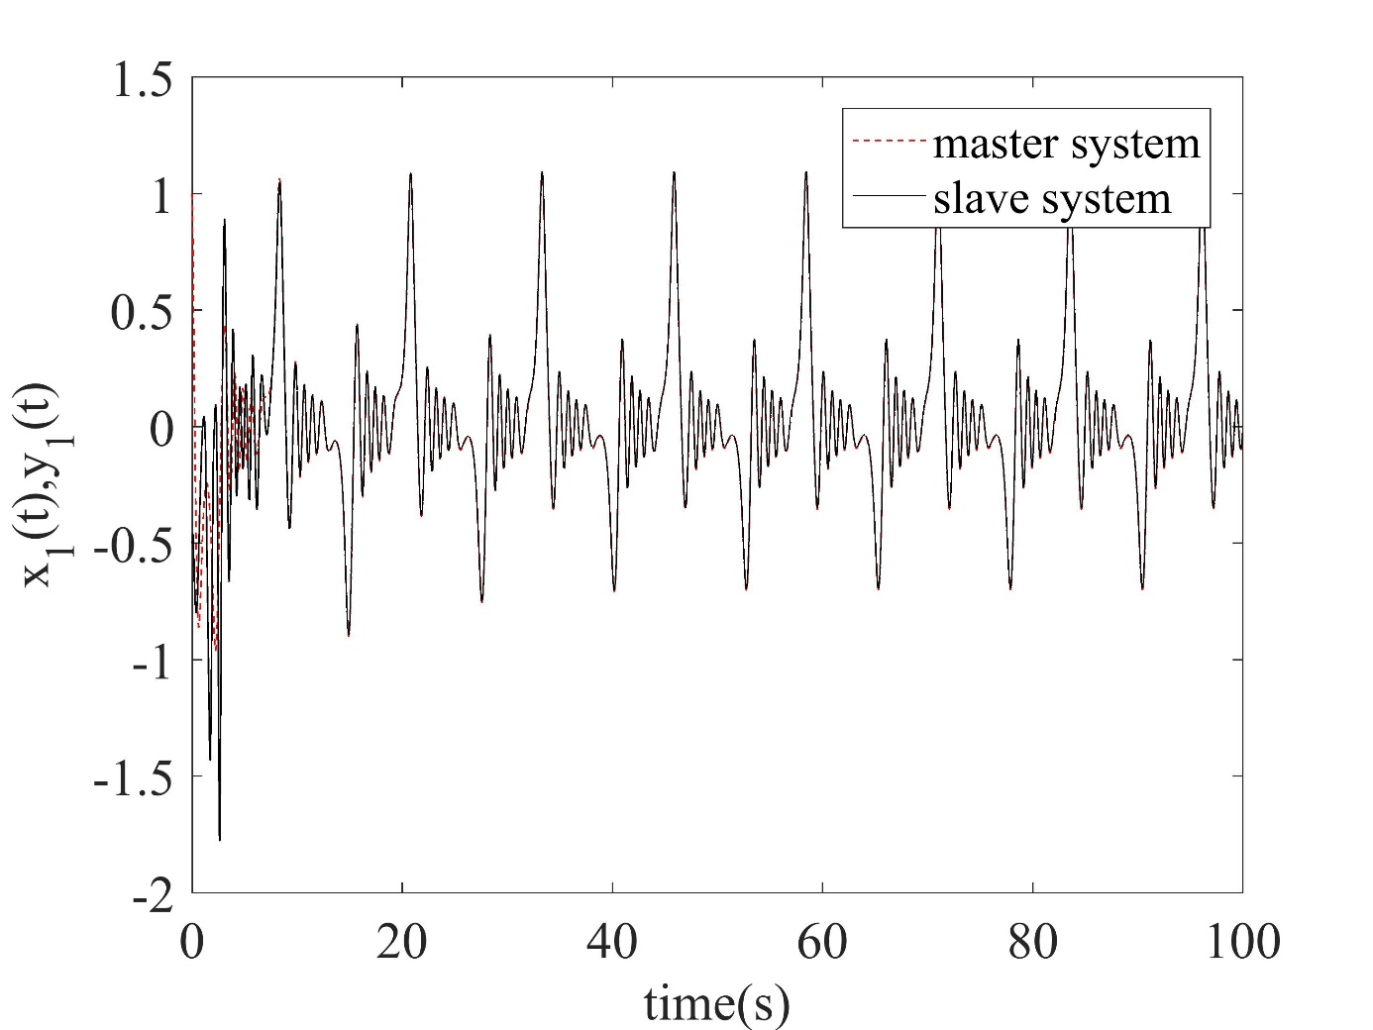

**(a)**

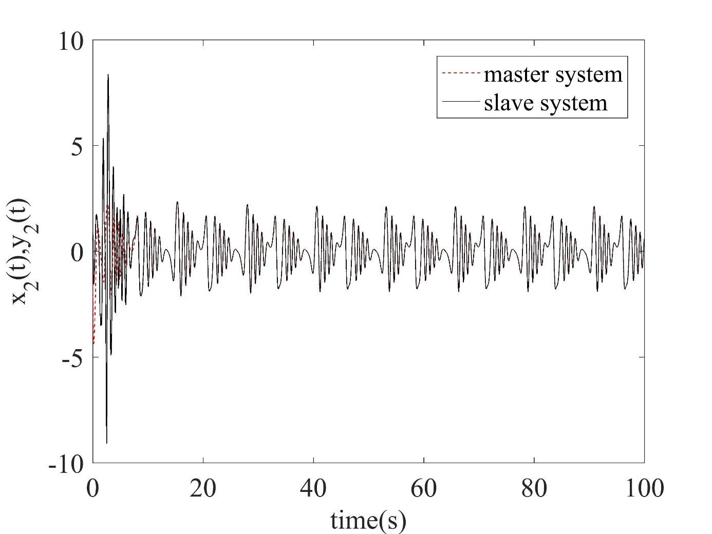

**(b)**

**Figure 1:** Time history of the master and slave state variables; (a) first state variable, (b) second state variable

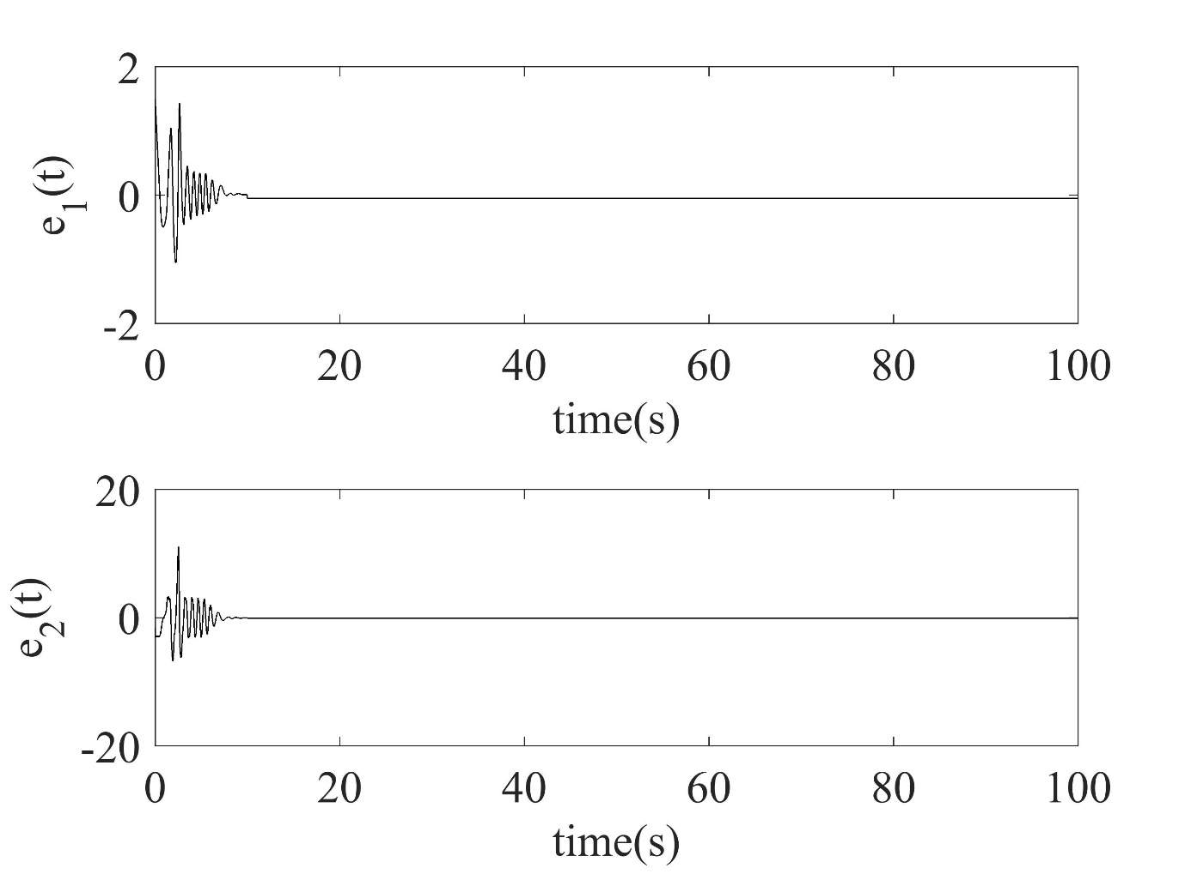

**Figure 2:** Time history of the synchronization error

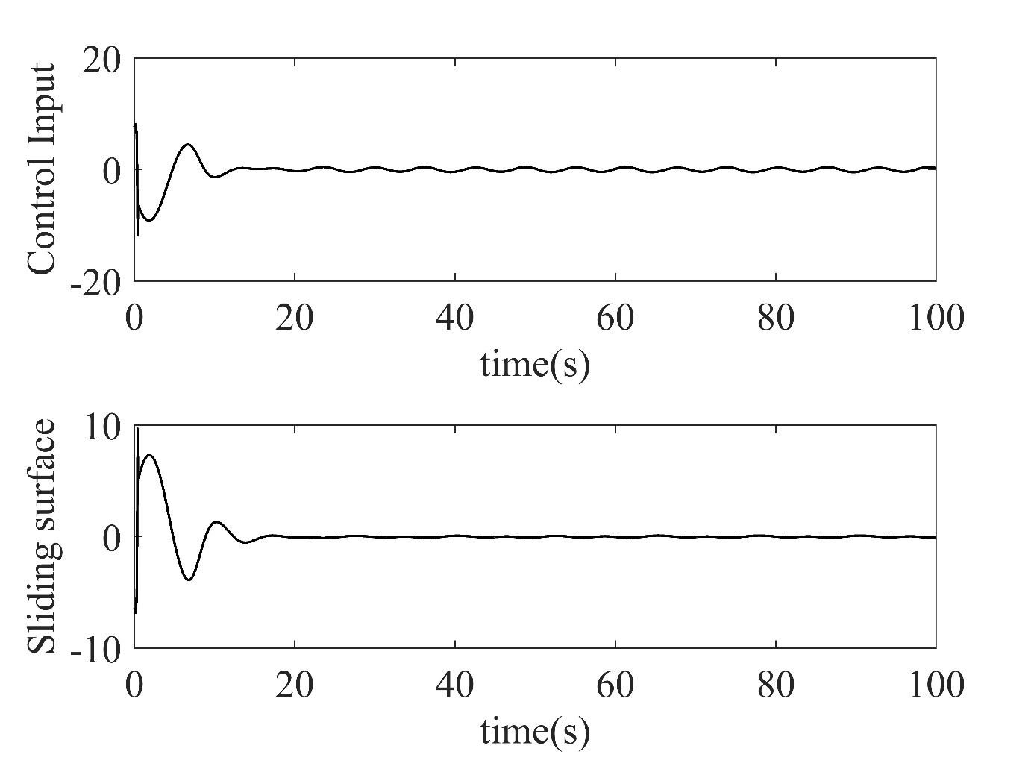

**Figure 3:** (a) Time history of the control action, (b) Time history of the sliding surface